ARTIFICIAL NEURAL NETWORKS

An ANN is based on a collection of connected units or nodes which loosely model the [neurons](https://en.wikipedia.org/wiki/Neuron) in a biological brain. An artificial neuron that receives a signal then processes it and can signal neurons connected to it. The "signal" at a connection is a [real number](https://en.wikipedia.org/wiki/Real_number), and the output of each neuron is computed by some non-linear function of the sum of its inputs. The connections are called *edges*. Neurons and edges typically have a [*weight*](https://en.wikipedia.org/wiki/Weight_(mathematics)) that adjusts as learning proceeds. The weight is updated to reduce the loss. Signals travel from the first layer (the input layer), to the last layer (the output layer), possibly after traversing the layers multiple times.

IMPLEMENTATION:

Import all the necessary libraries and load the csv file into the dataframe.

Split the data into train and test in the ratio 70:30

The data is normalised to fit in the range [0,1]

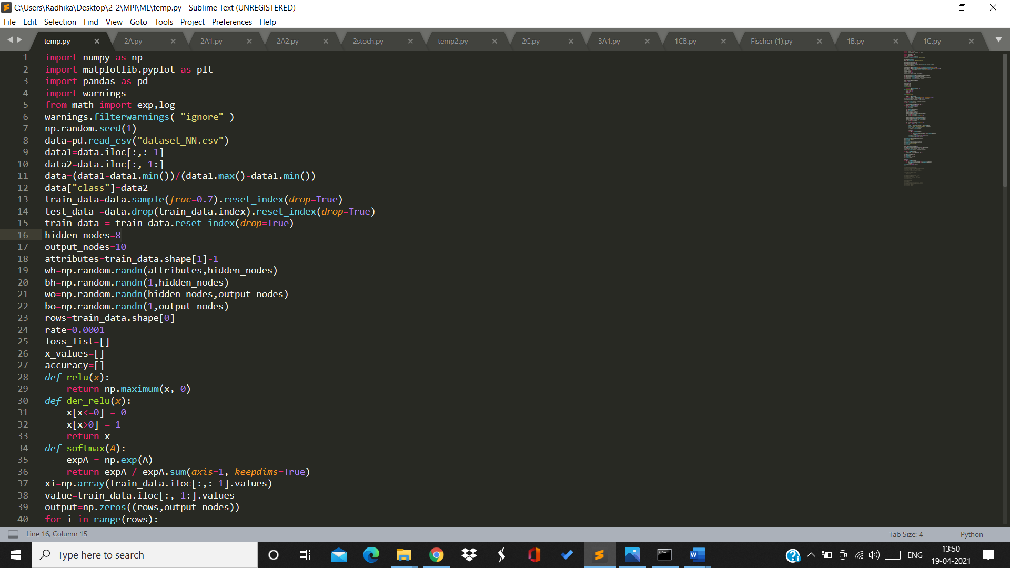

Number of input nodes=6

Number of output nodes=10

Number of hidden layers=1

Number of nodes in hidden layer=8

Initialise the weight vectors with random values

Learning rate=0.0001

Relu function is chosen as activation function for hidden layer

Softmax function is chosen as activation function for output layer



In the forward propagation, ao is calculated which is our predicted output.

In the back propagation, weights are updates after calculation gradient of the cross entropy function.

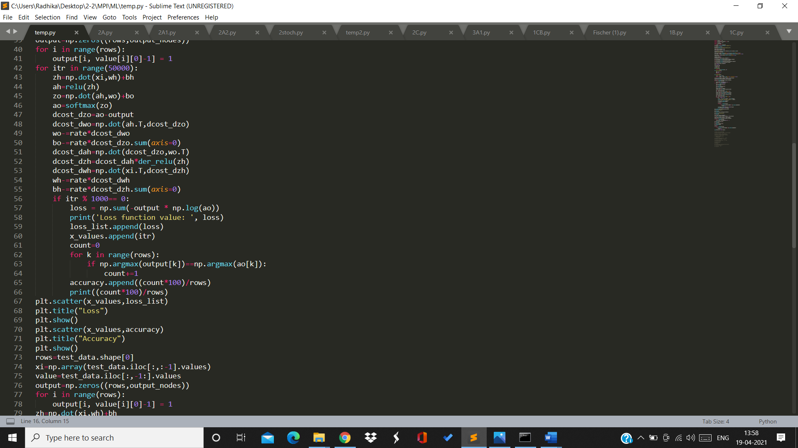

For 2 hidden layers:

Input nodes=6

Output nodes=10

Hidden layer1 nodes=8

Hidden layer2 nodes=8

Relu function is used for both the hidden layers and softmax for output layer.

**RESULTS:**

**1 hidden layer:**

For rate 0.0001

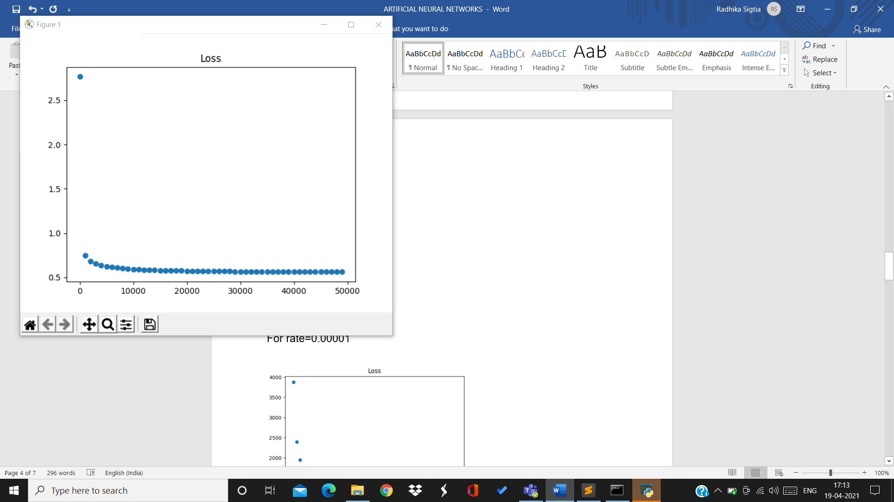

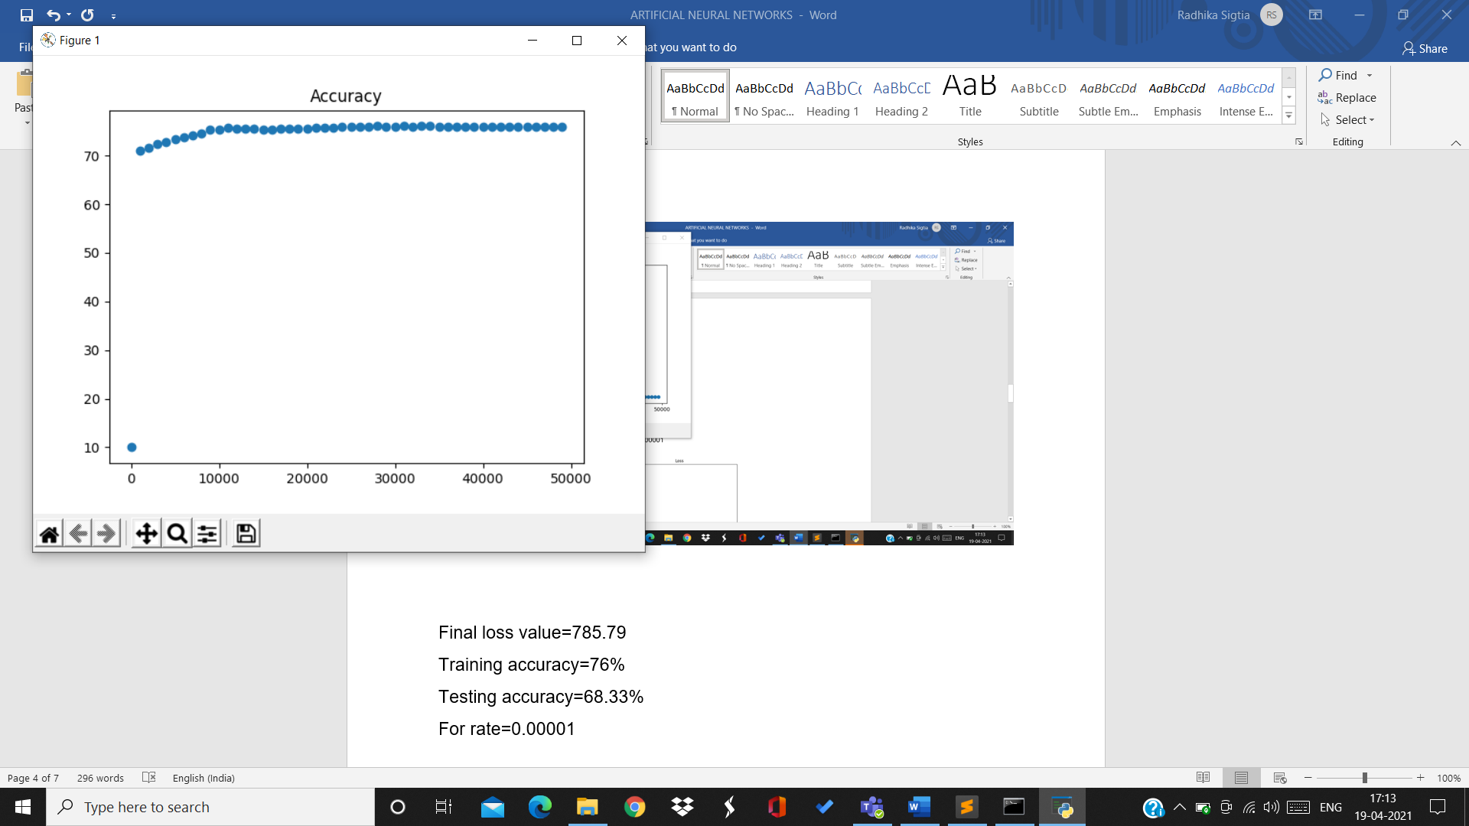

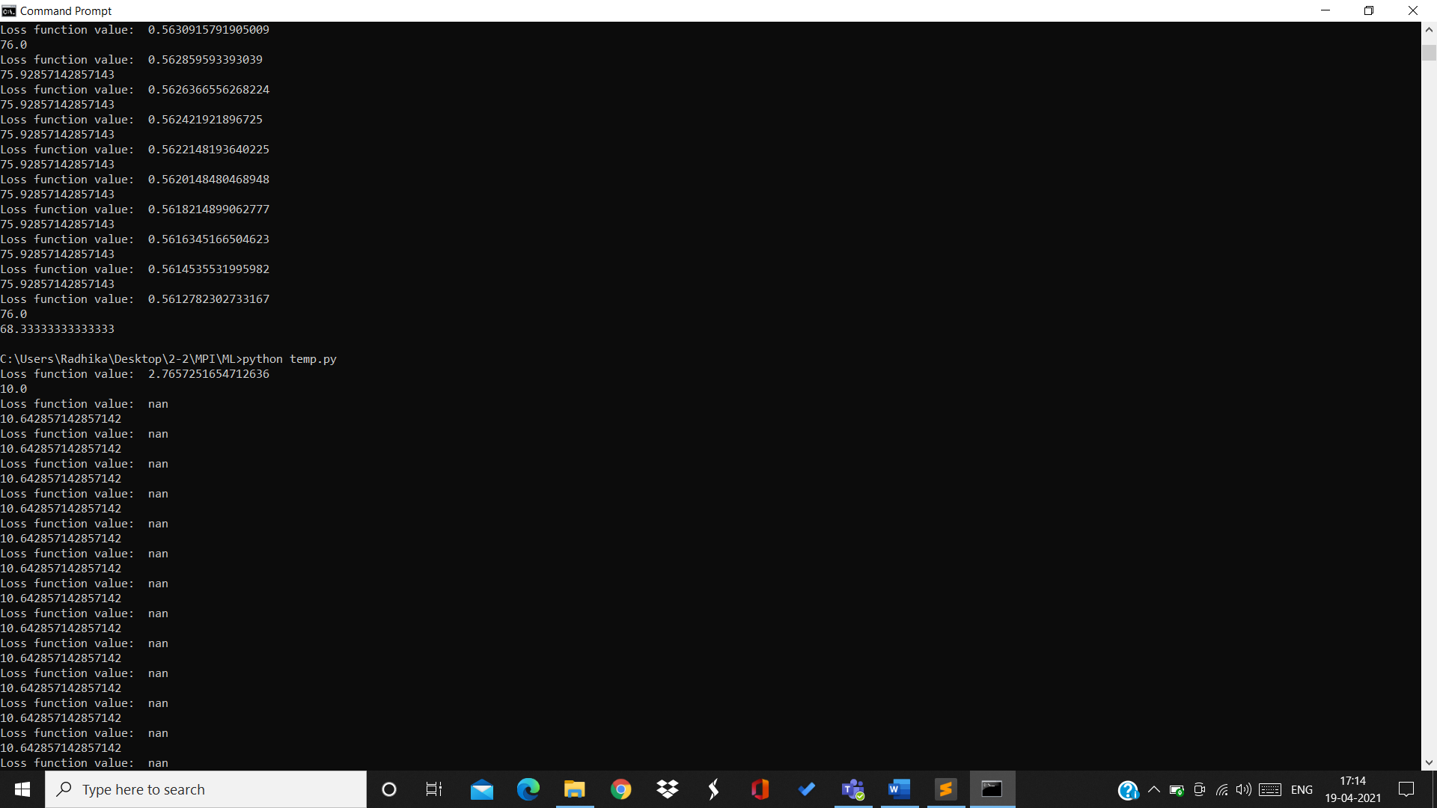

Final loss value=0.56

Training accuracy=76%

Testing accuracy=68.33%

For rate=0.00001:

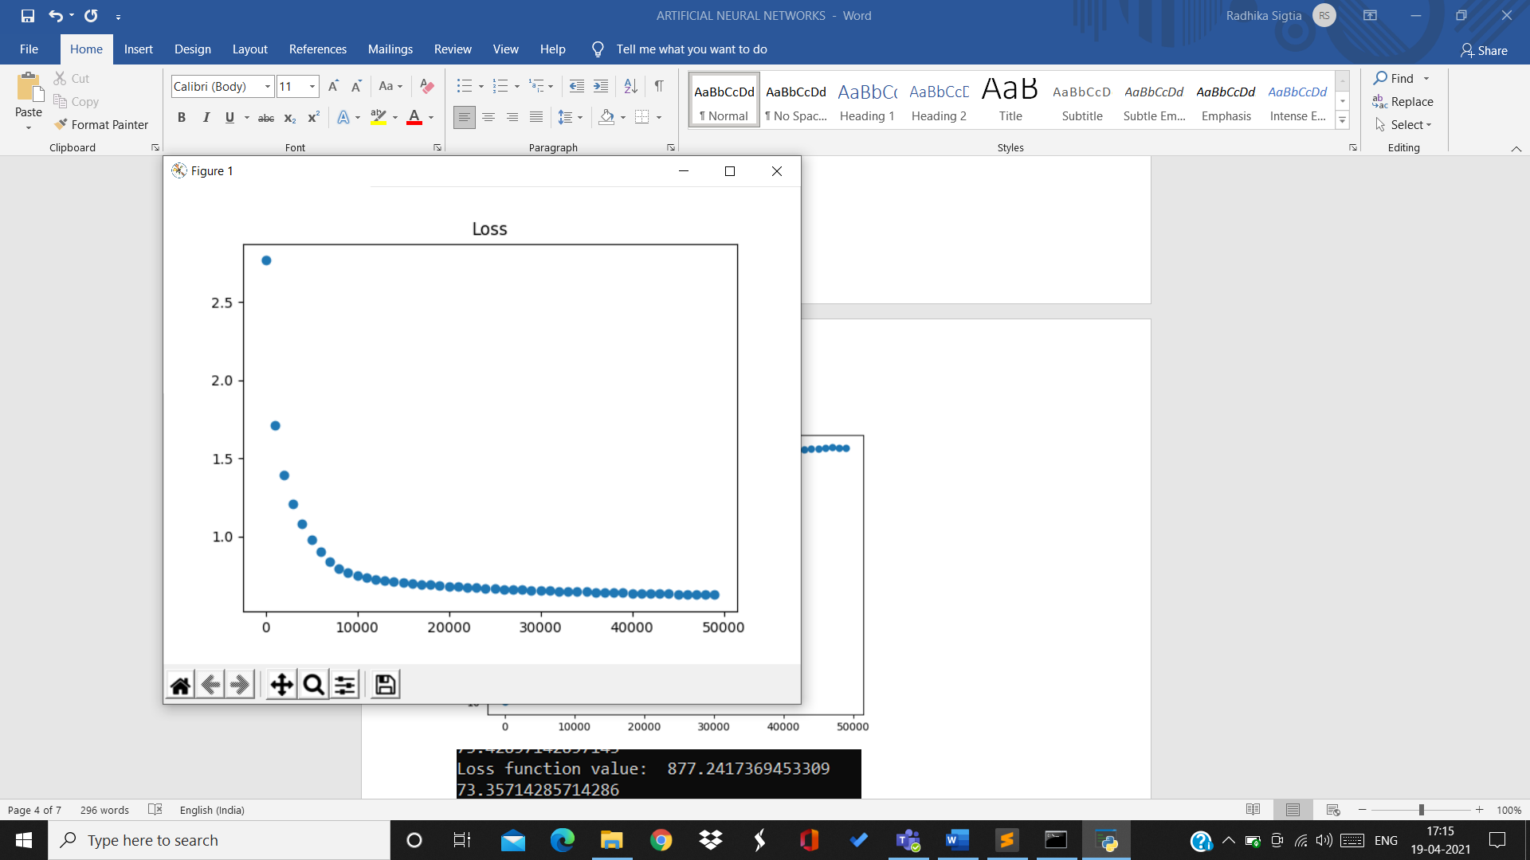

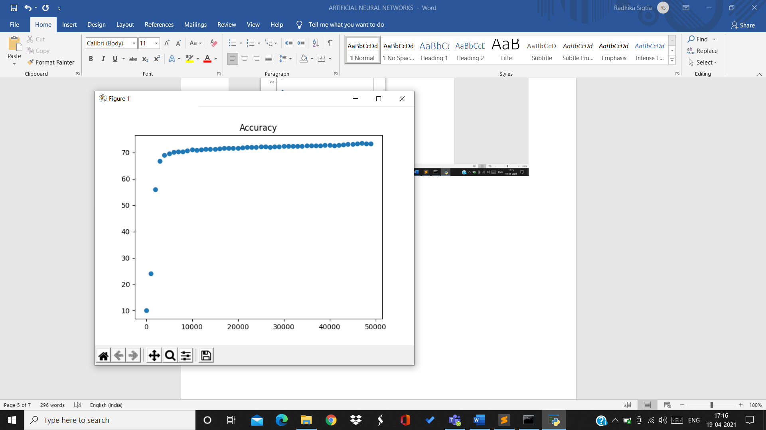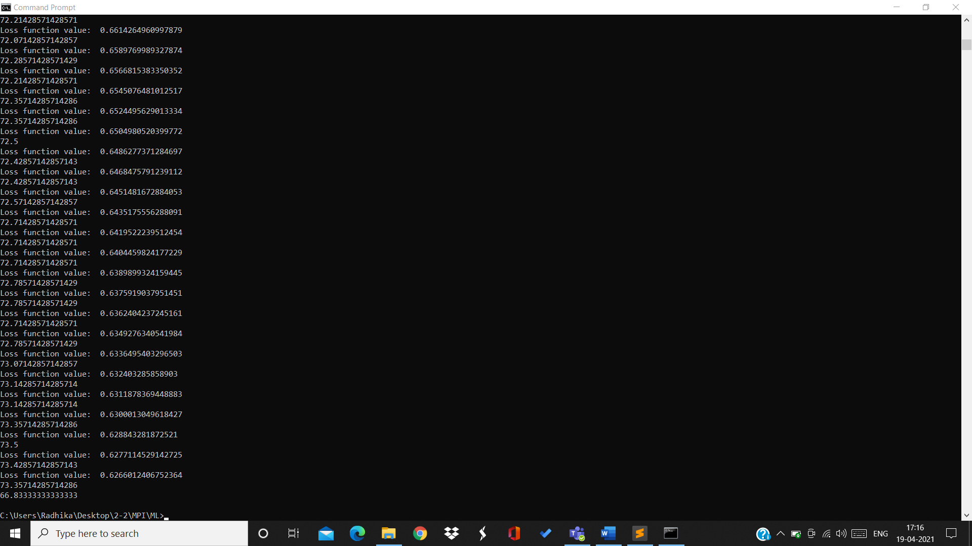

Final loss value=0.626

Training accuracy=73.35%

Testing accuracy=66.83%

For rate=0.00005:

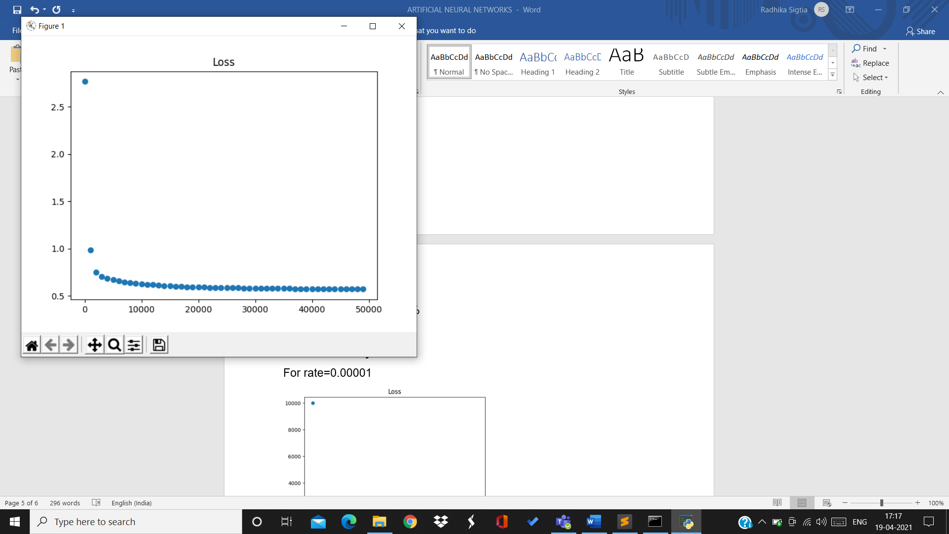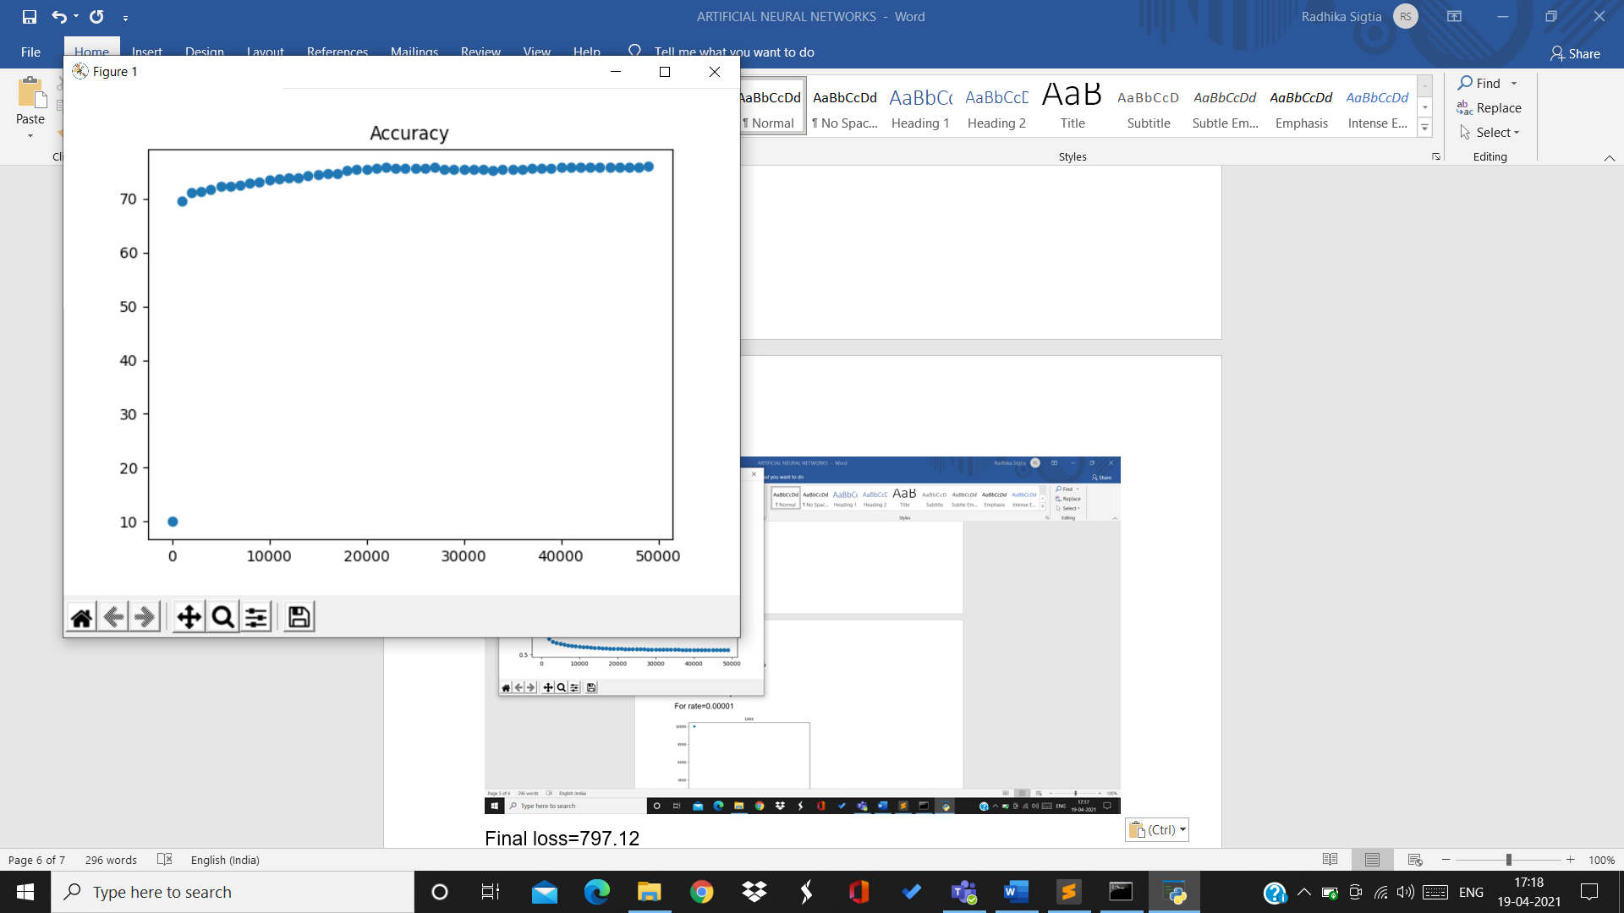

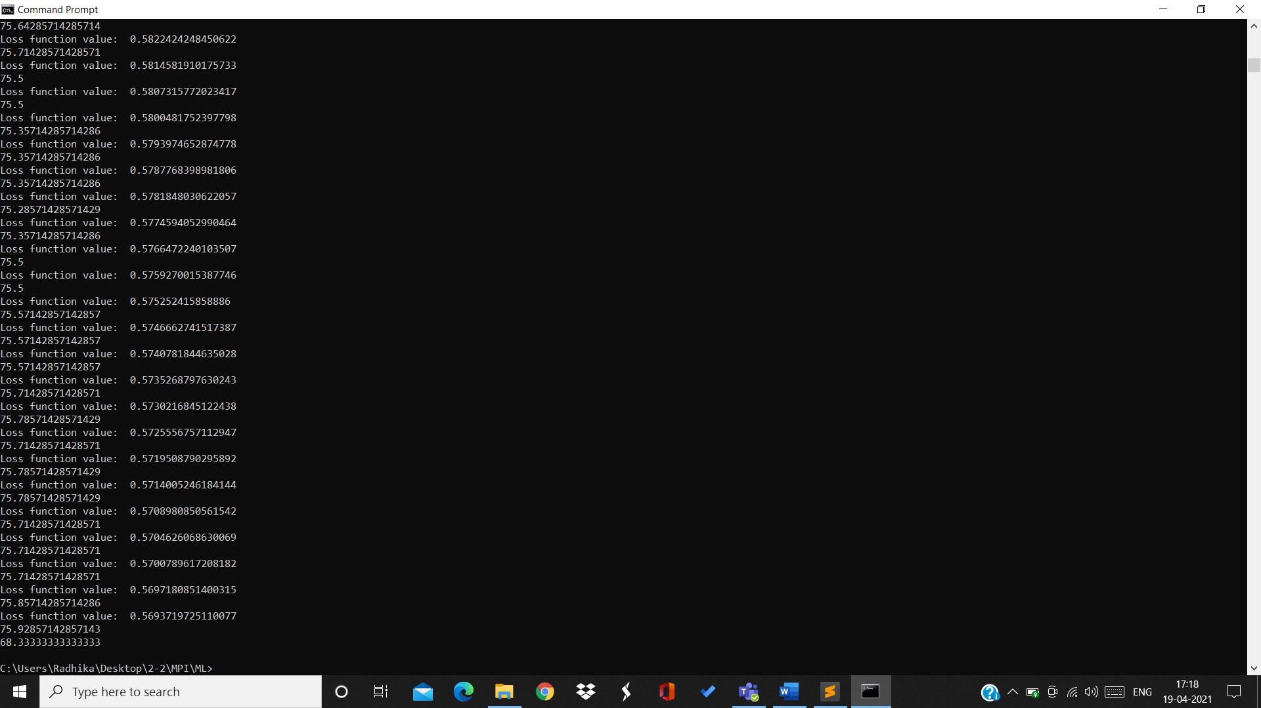

Final loss=0.569

Training accuracy=75.92%

Testing accuracy=68.33%

**For 2 hidden layers:**

For rate=0.00001

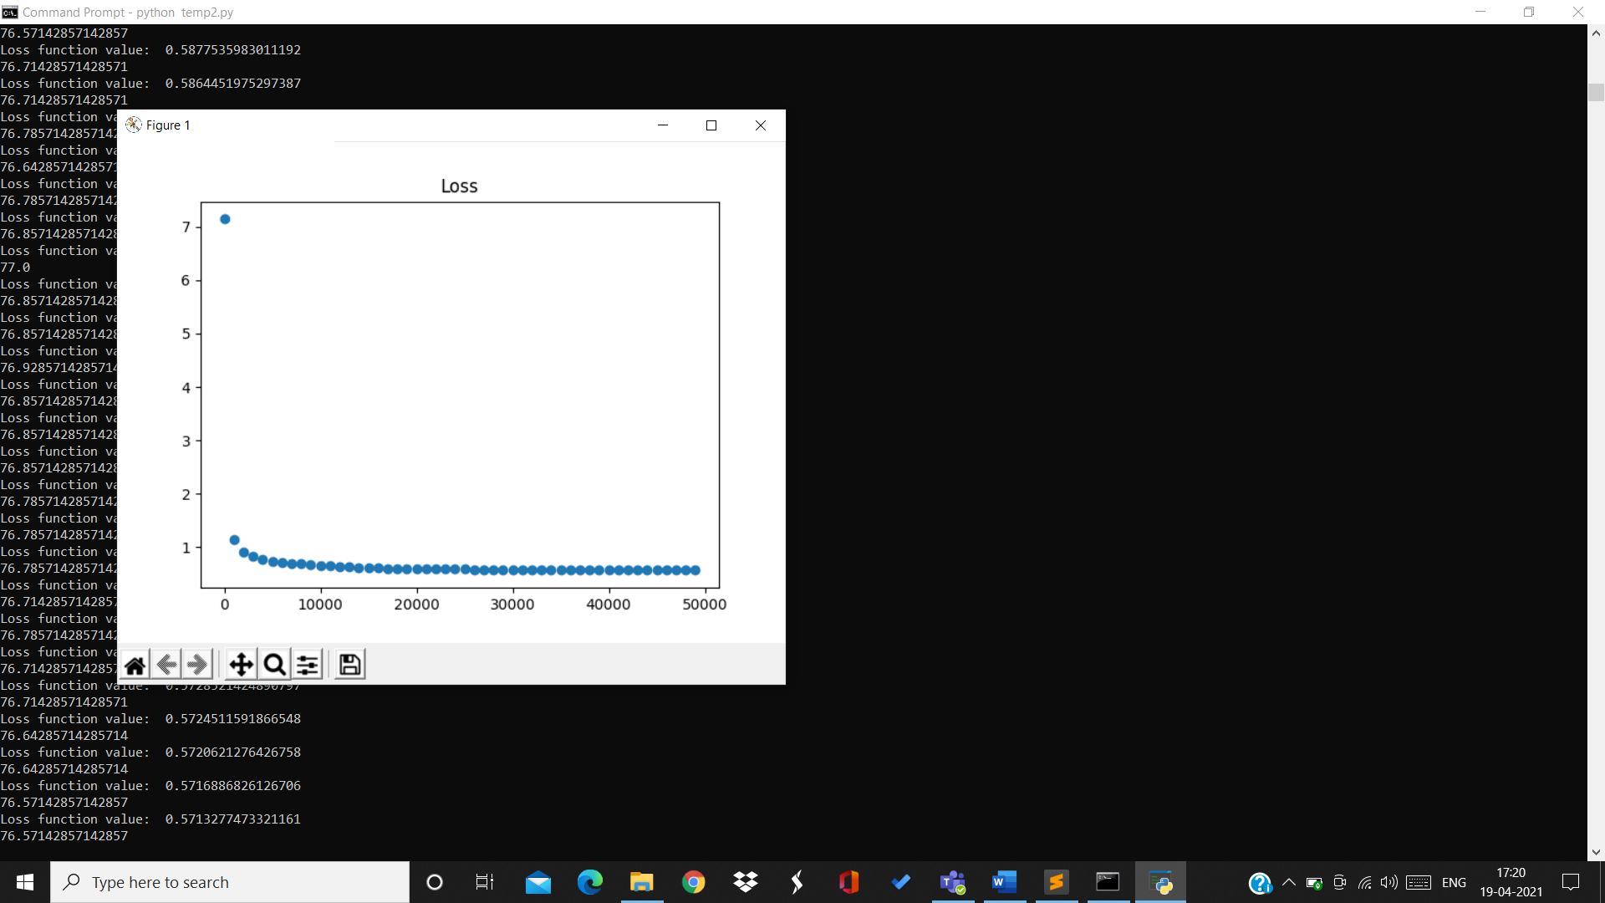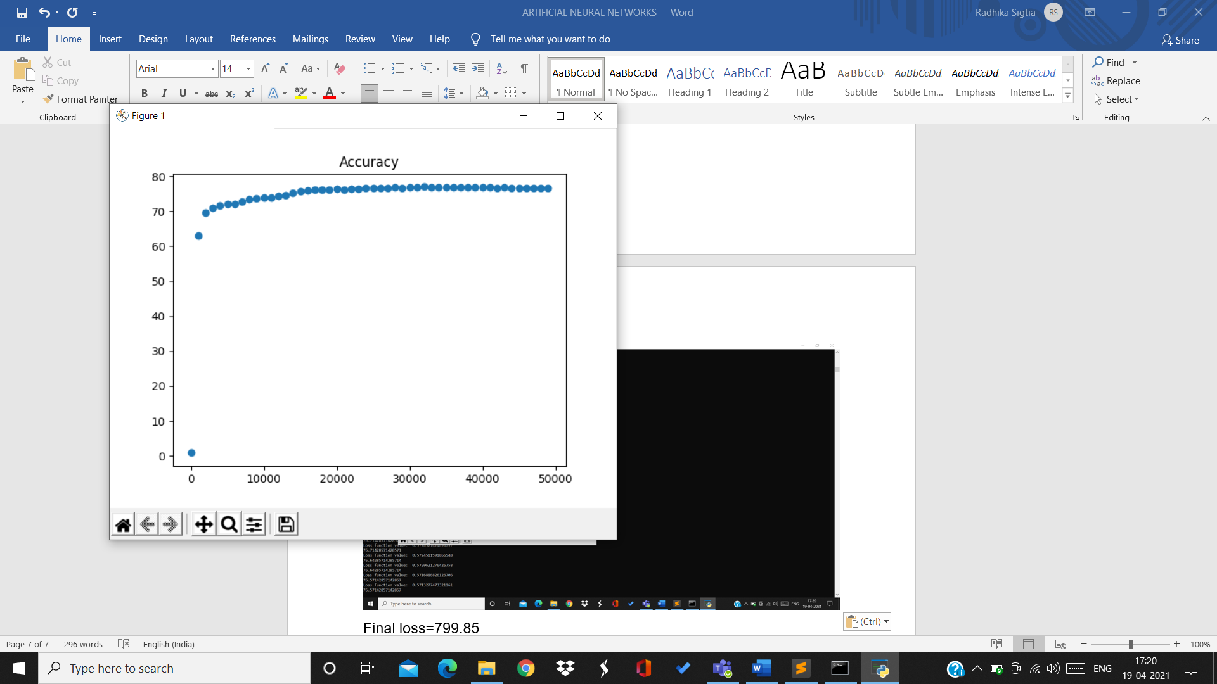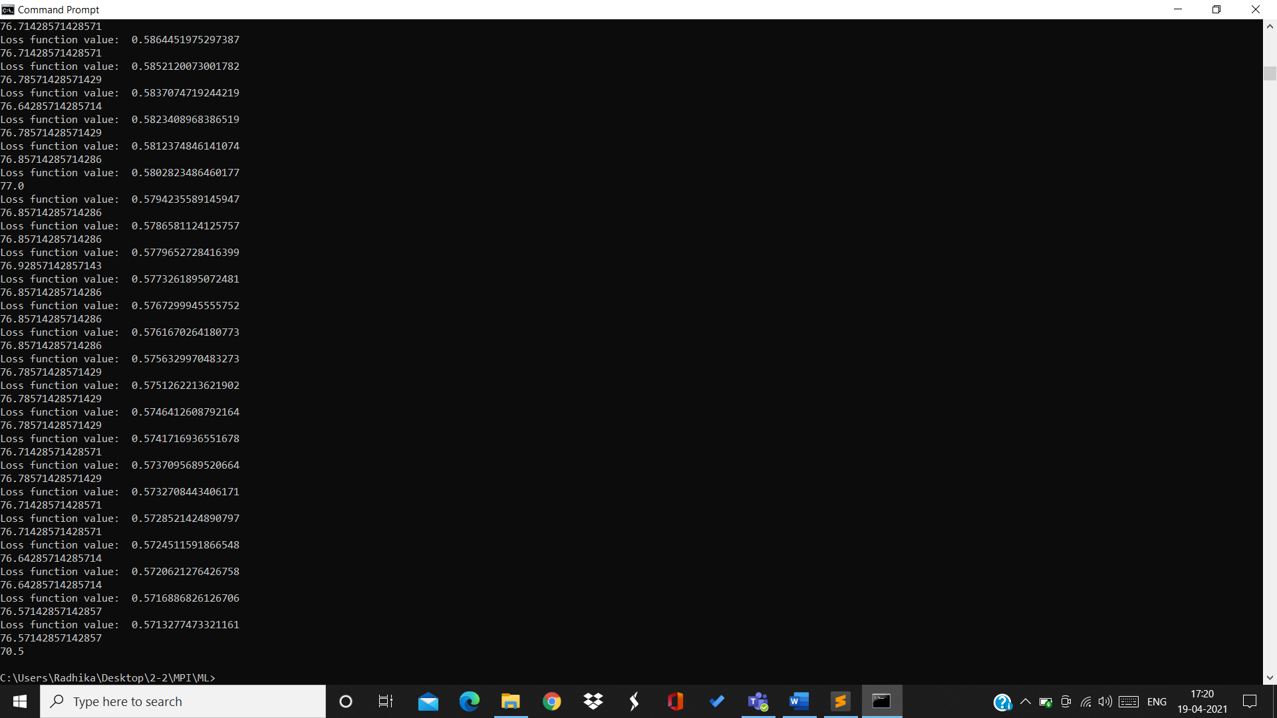

Final loss=0.571

Training accuracy=76.57%

Testing accuracy=70.5%

For rate=0.00002:

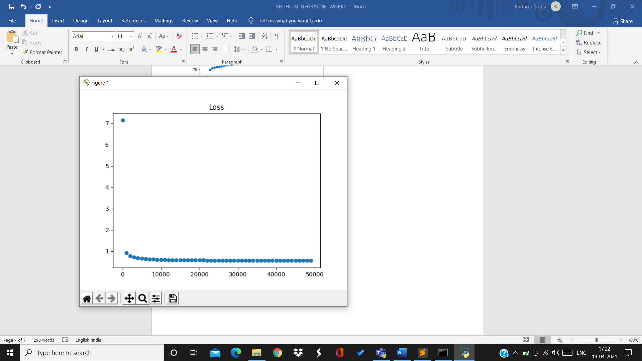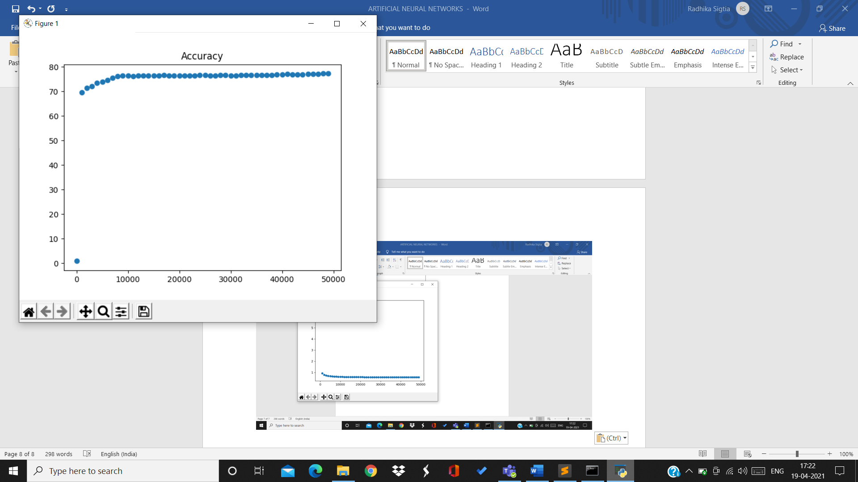

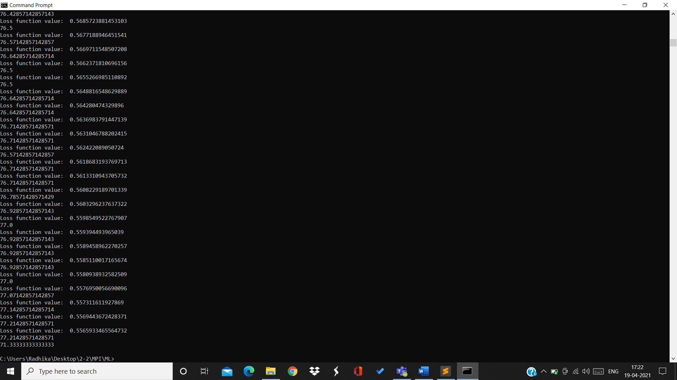

Final loss=0.55

Training accuracy=77.21%

Testing accuracy=71.33%

For rate=0.00005:

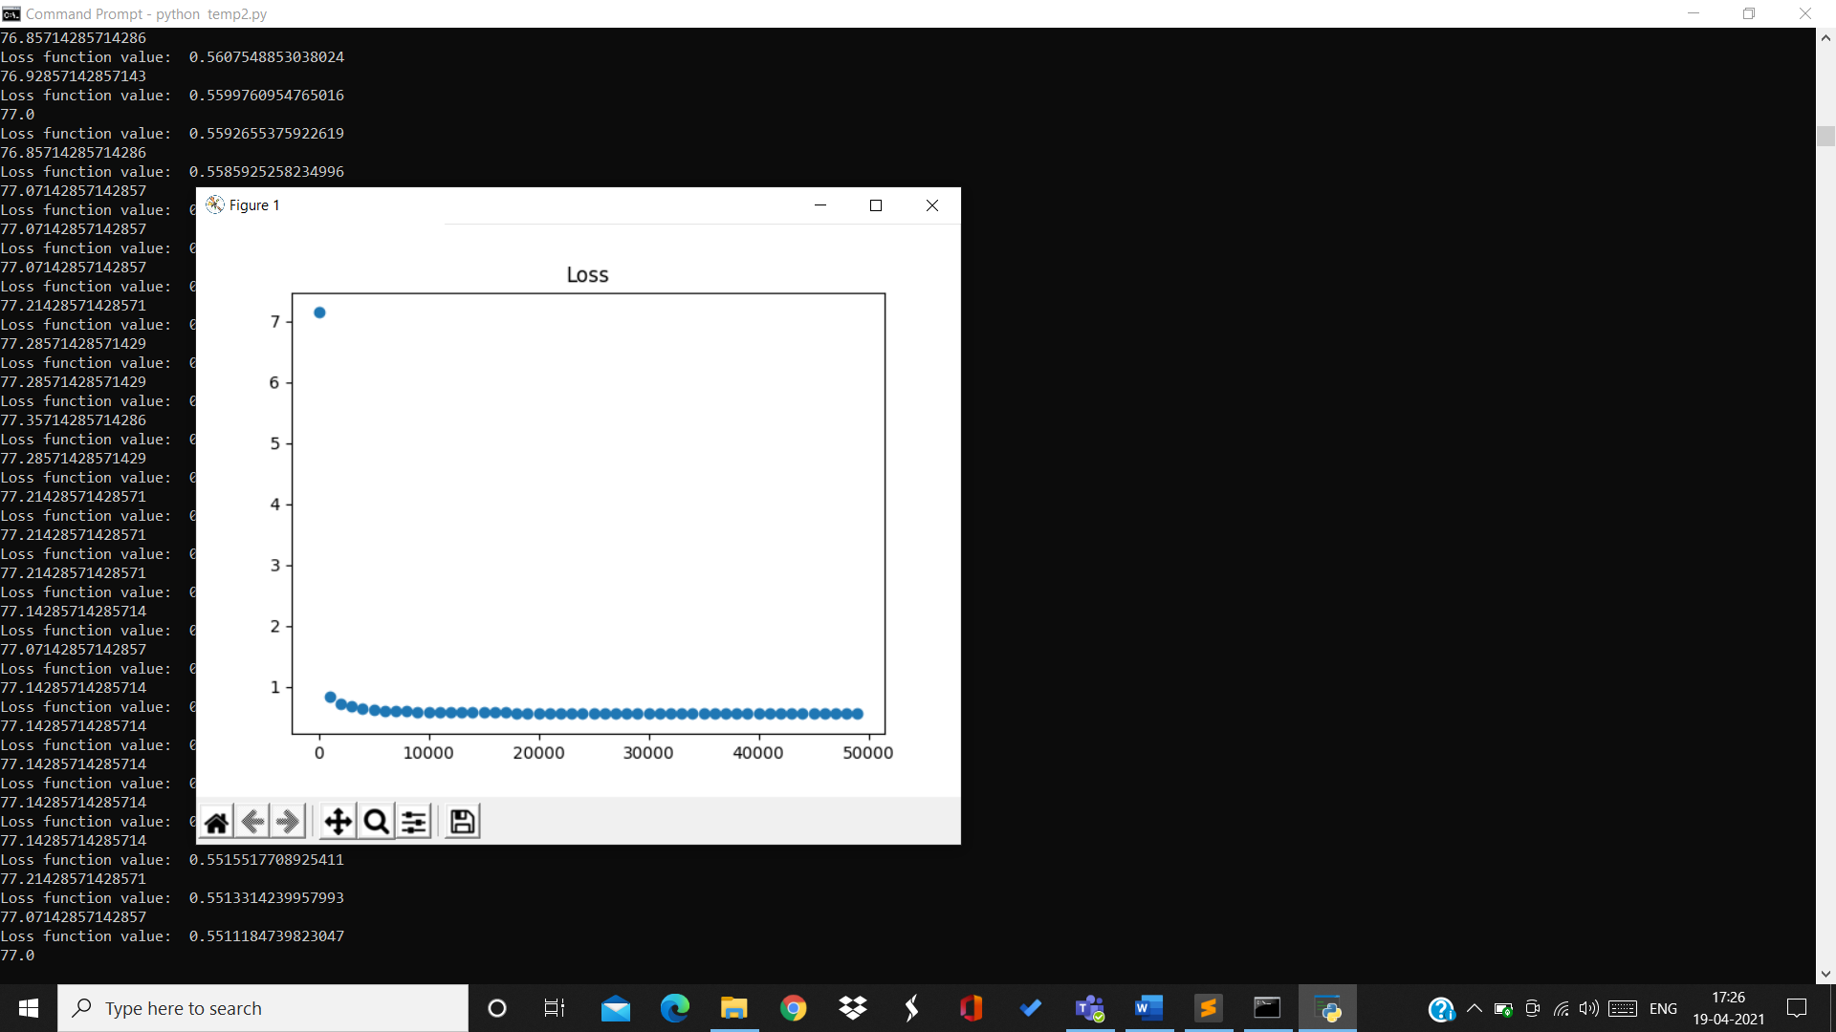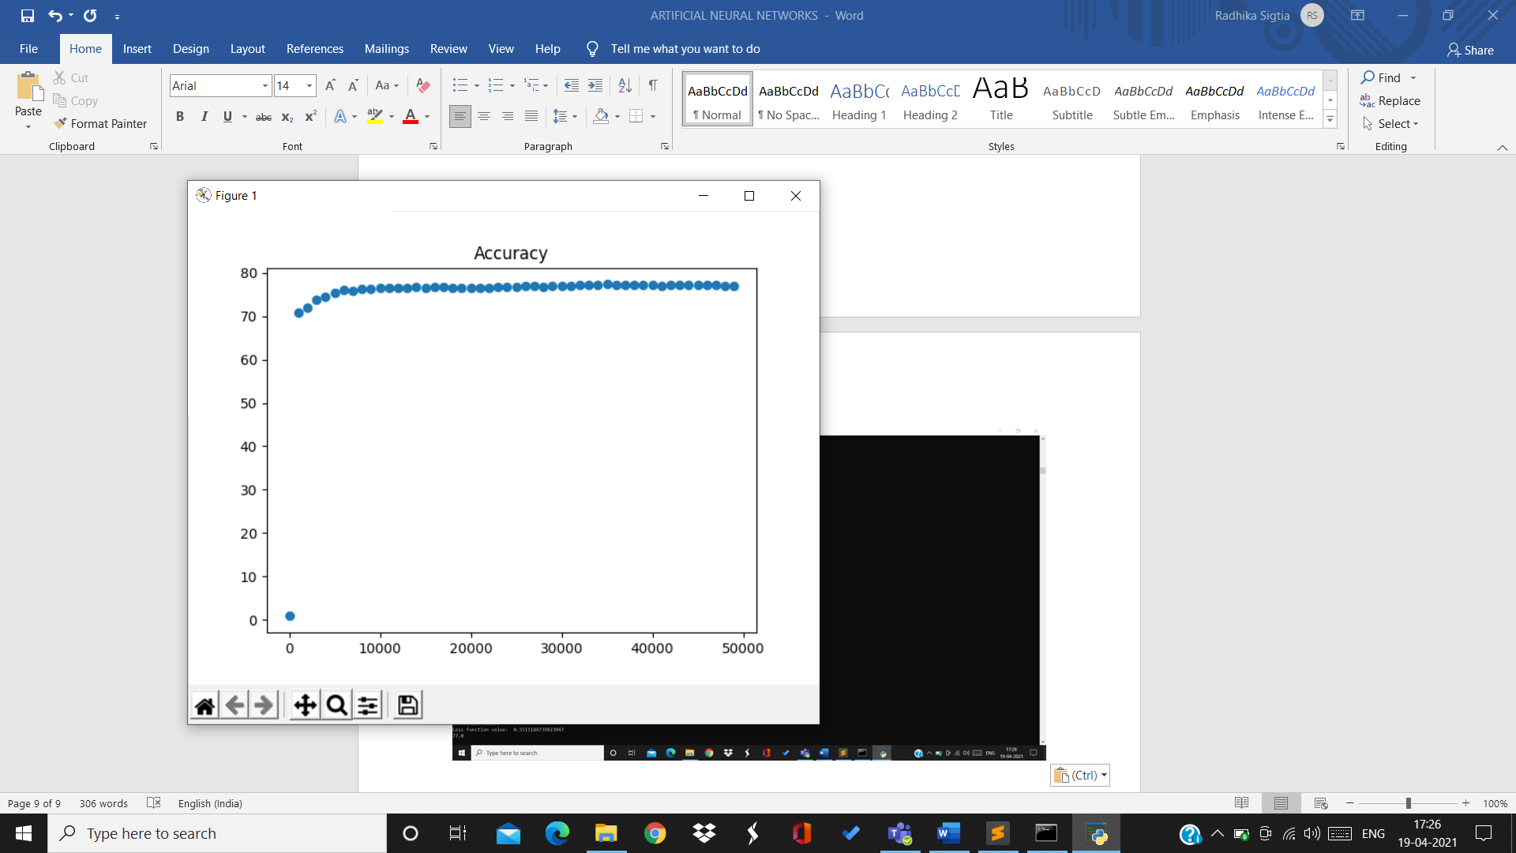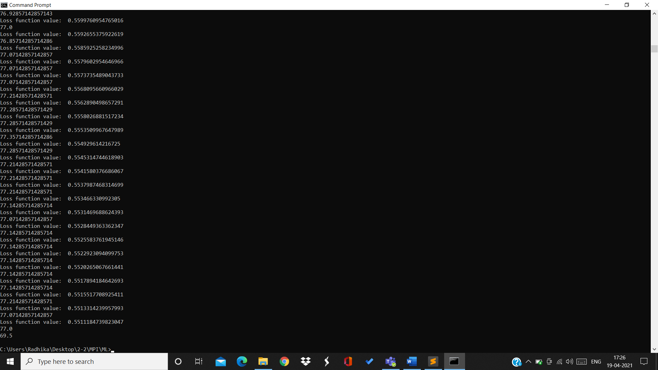

Final loss=0.55

Training accuracy=77%

Testing accuracy=69.5%

BY:

Radhika Sigtia 2019A7PS0094H

Bathini Akash 2019A7PS0065H

Sharvani Reddy 2019A7PS0050H